**VISION FOR THE BLIND (OBJECT DETECTION)**

**A MINOR PROJECT REPORT**

***Submitted by***

**JAVED KHAN (2016-333-024)**

***In partial fulfillment for the award of the degree of***

**BACHELOR OF TECHNOLOGY**

***Under the supervision of***

**MR. ZEESHAN ALI HAQ**



**Department of Computer Science**

**School of Science and Technology**

**JAMIA HAMDARD**

**New Delhi-110080**

**(2019)**

DECLARATION

I Javed Khan(2016-333-024),student of BACHELOR OF ENGINEERING AND TECHNOLOGY**(BTECE)** hereby declare that the dissertation entitled “**VISION FOR THE BLIND (OBJECT DETECTION)”** which is being submitted by me to the Department of Computer Science, JamiaHamdard, New Delhi in partial fulfillment of the requirement for the award of the degree of **BACHELOR OF ENGINEERING AND TECHNOLOGY(BTECE),** is my original work and has not been submitted anywhere else for the award of any Degree, Diploma, Associate ship, Fellowship or other similar title or recognition.

Javed Khan

Date:

Place:

**CERTIFICATE FROM SUPERVISOR**

I/We do hereby recommend that the thesis work prepared under my/our supervision by Javed Khan (2016-333-024), titled “VISION FOR THE BLIND (OBJECT DETECTION)”be accepted in the partial fulfillment of the requirements of the degree of Bachelor of Engineering and Technology for Examination.

Date:

Place:

Countersigned by Dean:

**ACKNOWLEDGEMENT**

We would like to express our sincere appreciation and gratitude to my respected guide, **Mr. Zeeshan Ali Haq**, and **Head of Department Computer Science and Technology**, for his support and help during our work. He has been a great source of knowledge and has inspired us with many ideas which are very useful for this research. His guidance, encouragement and patience have made this thesis possible. We are very grateful to **Head Department of Computer Science and Technology**,**JamiaHamdard** and all the other teachers and staff members of the department for their invaluable advice and assistance during our studies and project work. We extend our sincere gratitude to our Director for his encouragement and support which removed all hurdles that came on the way of completion of our work.

Javed Khan

Date:

Place:

**CONTENTS**

List of Figures 6

List of Abbreviation 7

1. Objective 8
2. Introduction 10
3. Literature Survey 11
4. Problem Statement 17
5. Software Requirement Specification 18
6. Overall Description 19
7. Specific Requirement 20
8. Conclusion 23
9. Bibliography 24

**List of figuresPage**

**Figure 1:-** Arduino UNO 11

**Figure 2**:- ECHO/Ultrasonic sensor 13

**Figure 3**:- Beeper/Buzzer 14

**Figure 4**:- Ultrasonic sensor front and rear 15

**Figure 5**:- Incident and reflected wave concept of 15

Ultrasonic sensor

**Figure 6**:- Assembled hardware components 22

**List of Abbreviations:-**

OD: Object Detection

IEEE: Institute for Electrical and Electronic Engineering

SRS: Software Requirements Specification

UI: User Interface

**Objective**

The Project idea is basically divided into two sub problems:

a) Detection of object

b) Providing a virtual vision to the blind people

The project objective is to implement a system running in accordance with objective components in an optimum way. Various algorithms and methodologies are studied and proper analysis will be done to achieve the goal. This kind of an object detection embedded system can be widely used in daily life of those people who are physically disabled or are unable to see in real life, also as a reverse parking sensor for vehicles and for various futuristic approach based on the inbuilt specifications provided by the Arduino and Echo/Ultrasonic sensor .

***VISION FOR THE BLIND***

***(OBJECT DETECTION)***

**Introduction**

The main objective of this project is to provide a virtual vision about the object in front to the people who unfortunately cannot see the environmental things in the real world. Environmental things may include anything which we all can fortunately see in the world whether it might be any obstacle in front of us or a person standing in front of us or far away from us. The futuristic things are well developed as we all know so why don’t we provide a vision to the people who just roam around seeking for others help and using a stick which is almost close to the blindness.

To develop an objectdetector, Ihave used Arduino as the main component providing various coding elements to the fulfillment of the project. It contains all the necessary required files or compiling units inbuilt so fortunately there is no need to define or provide any library function externally.

Also this project includes components like the transmitting and receiving sensor(commonly known as the ECHO/Ultrasonic sensor) and a beeper. Echo sensor will basically send waves which will be then received by the sensor after reflection form a surface and accordingly the beeper will increment or decrement the sound frequency based upon the distance of the sensor with the object. For example if the object is far off from the sensor then the sound will be heard at long intervals of time and similar is the vice-versa case.

**Literature Survey**

**ARDUINO UNO:-**

The Arduino UNO is an open-source microcontroller board based on the [Microchip](https://en.wikipedia.org/wiki/Microchip_Technology) [ATmega328P](https://en.wikipedia.org/wiki/ATmega328P) microcontroller and developed by [Arduino.cc](https://en.wikipedia.org/wiki/Arduino). The board is equipped with sets of digital and analog input/output (I/O) pins that may be interfaced to various expansion boards (shields) and other circuits. The board has 14 Digital pins, 6 Analog pins, and programmable with the [Arduino IDE](https://en.wikipedia.org/wiki/Arduino#Software) (Integrated Development Environment) via a USB (Universal Serial Bus) cable. It can be powered by a USB cable or by an external 9 volt battery, though it accepts voltages between 7 and 20 volts.

Arduino UNO can be better understood using the below set of figures and illustrations:-

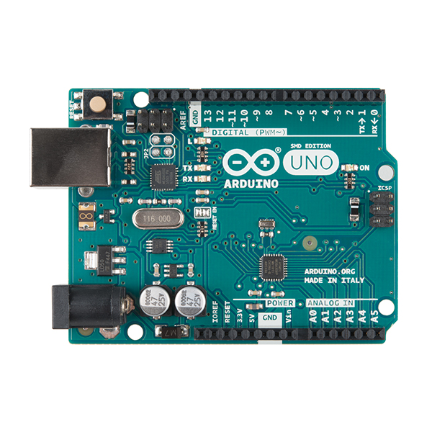

**FIGURE 1: Arduino UNO**

### **General Pin functions:-**

* **LED**: There is a built-in LED driven by digital pin 13. When the pin is HIGH value, the LED is on, when the pin is LOW, it's off.
* **VIN**: The input voltage to the Arduino board when it's using an external power source (as opposed to 5 volts from the USB connection or other regulated power source). You can supply voltage through this pin, or, if supplying voltage via the power jack, access it through this pin.
* **5V**: This pin outputs a regulated 5V from the regulator on the board. The board can be supplied with power either from the DC power jack (7 - 20V), the USB connector (5V), or the VIN pin of the board (7-20V). Supplying voltage via the 5V or 3.3V pins bypasses the regulator, and can damage the board.
* **3V3**: A 3.3 volt supply generated by the on-board regulator. Maximum current draw is 50 mA.
* **GND**: Ground pins.
* **IOREF**: This pin on the Arduino board provides the voltage reference with which the microcontroller operates. A properly configured shield can read the IOREF pin voltage and select the appropriate power source or enable voltage translators on the outputs to work with the 5V or 3.3V.
* **Reset**: Typically used to add a reset button to shields which block the one on the board.

**AUTOMATIC RESET**:-

Rather than requiring a physical press of the reset button before an upload, the Arduino Uno board is designed in a way that allows it to be reset by software running on a connected computer. One of the hardware flow control lines of the ATmega8U2/16U2 is connected to the reset line of the ATmega328 via a 100 nanofarad capacitor. When this line is asserted (taken low), the reset line drops long enough to reset the chip.

This setup has other implications. When the Uno is connected to a computer running Mac OS X or Linux, it resets each time a connection is made to it from software (via USB). For the following half-second or so, the bootloader is running on the Uno. While it is programmed to ignore malformed data (i.e. anything besides an upload of new code), it will intercept the first few bytes of data sent to the board after a connection is opened.

**ULTRASONIC SENSORS:-**

Ultrasonic sensors or ultrasonic transducers are a type of acoustic sensor divided into three broad categories: transmitters, receivers and transceivers. Transmitters convert [electrical signals](https://en.wikipedia.org/wiki/Signal_(electrical_engineering)) into [ultrasound](https://en.wikipedia.org/wiki/Ultrasound), receivers convert ultrasound into electrical signals, and transceivers can both transmit and receive ultrasound. These sensors are widely used in a large number of applications such as RADAR (Radio Detection and Ranging), Embedded projects applications (used for distance measurements as the time between the transmitted and received signal gives the value of distance between the sensor and the object) etc.

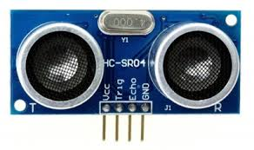

**FIGURE 2:- ECHO/ULTRASONIC SENSOR**

Ultrasonic Sensors includes a transmitting area denoted by ‘T’ and receiving area denoted by ‘R’ which are majorly involved in the transmitting and receiving of the waves/signals emitted by the sensor. Also it includes 4 pins namely Vcc (voltage pin=5v) Trig pin (for triggering of the pins connected with Arduino) and Echo pin (also connected to the Arduino) and the Ground pin denoted by ‘GND’ connected with the ground terminal of the Arduino.

**BEEPER:-**

A buzzer or beeper is an [audio](https://en.wikipedia.org/wiki/Sound) signaling device, which may be [mechanical](https://en.wikipedia.org/wiki/Machine), [electromechanical](https://en.wikipedia.org/wiki/Electromechanics), or [piezoelectric](https://en.wikipedia.org/wiki/Piezoelectricity). Typical uses of buzzers and beepers include [alarm devices](https://en.wikipedia.org/wiki/Alarm_devices), [timers](https://en.wikipedia.org/wiki/Timer), and confirmation of user input such as a mouse click or keystroke.

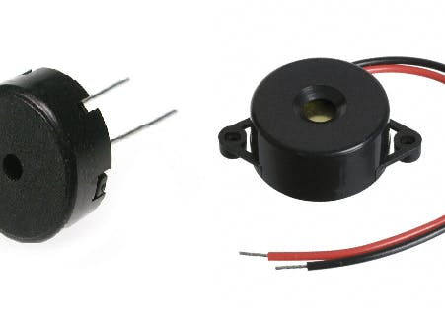

**FIGURE 3:- BUZZER OR BEEPER**

This component also holds great importance in this project as the distance will be evaluable by the blind person by the sound of the buzzer or beeper only. As the intensity/frequency of sound increases means that the object is nearby and the direction needs to be changed.

Buzzer or beeper is widely used in many applications in various structural designs such as water level detector, reverse parking sensors in the vehicles etc.

**Survey Part:**

**Ultrasonic sensors:-**

**Findings-**

The HC-SR04 ultrasonic sensor uses SONAR to determine the distance of an object just like the bats do. It offers excellent non-contact range detection with high accuracy and stable readings in an easy-to-use package from 2 cm to 400 cm or 1” to 13 feet.

The operation is not affected by sunlight or black material, although acoustically, soft materials like cloth can be difficult to detect. It comes complete with ultrasonic transmitter and receiver module.

As soon as any object or an obstacle comes in the path of ultrasonic sensor the transmitted signal/wave will return back in the form of the reflected wave from the reflecting surface giving us the value of the distance between the transmitter and the reflected surface. This distance can be easily evaluated or observed on the Arduino application in mobile phone or the PC application of the Arduino UNO.

Arduino UNO also makes it more compatible and easier to understand the basic programming concepts of C using the embedded C inbuilt concepts.

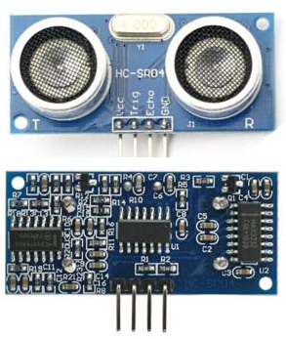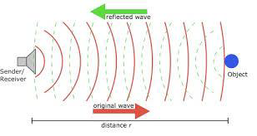

**FIGURE 4:- ULTRASONIC SENSOR FIGURE 5:- INCIENT AND REFLECTED WAVE FRONT AND REAR VIEW. CONCEPT.**

**Problem Statement**

Object detection is important for the interpretation of the nearby objects in applications such as intelligent man-machine interface and communication, intelligent visual surveillance, vision for the blind persons, reverse parking sensors applications in automobiles. There have been many computer models proposed for machine-based object detection. Individuals facing huge problems especially the blind people are unable to move around alone without any support of an individual.

This system will surely help out the problems faced in the near future using the advancements in technology.

**Proposed System:**

In the proposed system the problems regarding the vision and the places where people physically cannot reach are solved up and futuristic approach has also been applied in order to remove the problems faced by many individuals in day to day life.

**Software Requirement Specifications**

**Introduction**

* 1. **Purpose + Intended Audience**
* Object Detection is a strategy to detect an object or obstacle using modern technology tools (computer or mobile phones) and embedded system tools (Arduino, Raspberry pi etc.).
* This document is written for the researchers, software developers, advanced practitioners, documentation writers, testing team.
  1. **Scope**
* Object detection/vision for the blind has tremendous prospects in future.
* The bright future prospect of object detection is also proven with the fact that the technology is integrated in the mobile phones and personal computer technology as well.
* It will also enhance the limits of thinking for the physically disabled people.
  1. **References**
* Arduino applications software and website tools.
* Exploring Arduino and techniques (Jeremy Blum)
* Arduino workshop (John Boxall)
* Arduino project handbook (Mark Geddes)

**Overall Description**

* 1. **Product Perspective**

The software product being developed is for a new portable stand-alone device which functions as an interface between 2 peoples. Basically, it allows peoples to interact with each other. The product works with other software products like an Embedded Operating System, Databases for text and speech, Recognition and Translation Software.

* + 1. **Hardware Interface**

**CPU**: Intel Core 2 Quad Q9550 | AMD Phenom II X4 945 or equivalent.

**OS**: Windows 7, Windows 8.1, Windows 10 (64-bit versions only).

**VIDEO CARD**: NVIDIA GeForce GTS 450 | AMD Radeon HD 5670.

**SOUND CARD**: On Board.

**FREE DISK SPACE**: 3 GB.

* + 1. **Software Interface**
* Front End Client: Arduino UNO software based on Embedded C.
* Operating system:Window 7 or above.
  1. **Product Functions**
* User will be able to know about the objects near them using the ultrasonic sensors output.
* Can also be used as a reverse parking sensor for automobiles.
  1. **User Characteristics**
* **Peoples: -**Blindpeople or automobiles initially are the primary consumers of a Detection portal.
* **System Administrators: -** System administrators are primarily responsible for maintaining the Detection portal. Administrating includes providing the write code to the Arduino software in order to evaluate the proper functioning of the overall setup.
  1. **Constraints**
* **One should :**
* Have computer knowledge.
* Be interested in expressing his views on social responsibilities
* **U/I:**
* Should be popular to attract many users.
* Will never provide information to the end user directly, at least not anymore.
  1. **Assumptions and dependencies**

Our new system assumes that any object in front of range of the ultrasonic sensor is either an obstacle or an indication to change the direction of the user.

* 1. **Apportioning of Requirements**

Multiple direction (front, rear, left, right) object detections might be apportioned in future versions.

**Specific Requirements**

* 1. **External Interface Requirements**
     1. **Arduino Application**

The actual program that will perform the operations is written in Embedded C. All data will be stored in a database in the form of distance values the user has faced in the nearby environment.

* + 1. **Power supply**

Power supply in the form of either a mobile phone device or a battery is necessity in order to provide +5v supply for the overall functioning of the Arduino.

* 1. **Performance Requirements**

The system will supportonly one user at a time but can be effectively used for multiple direction distance evaluations. This statement provides a general sense of reliability when the system is under load. Arduino UNO can be connected to the power through the USB cable for a substantially long period of time without any distortions in the performance of the overall device.

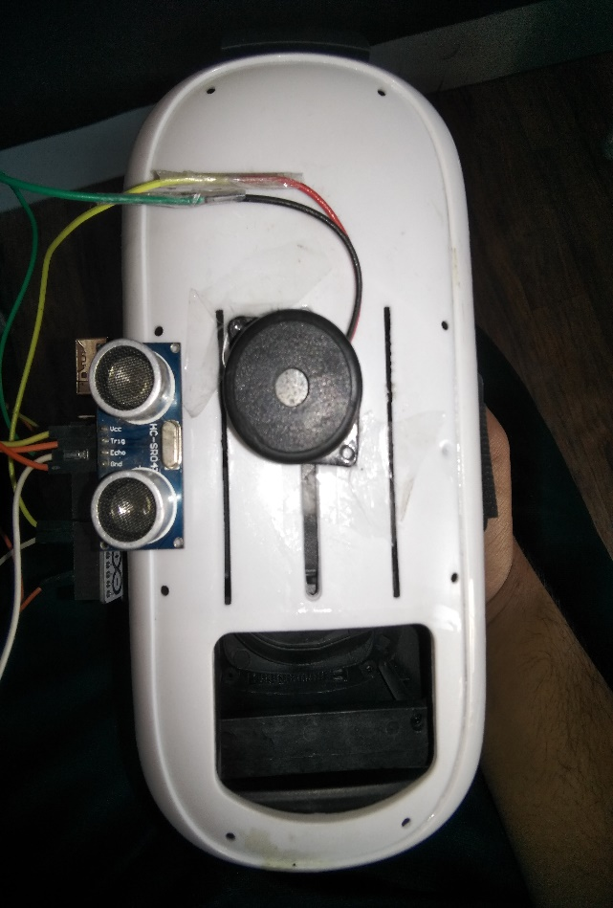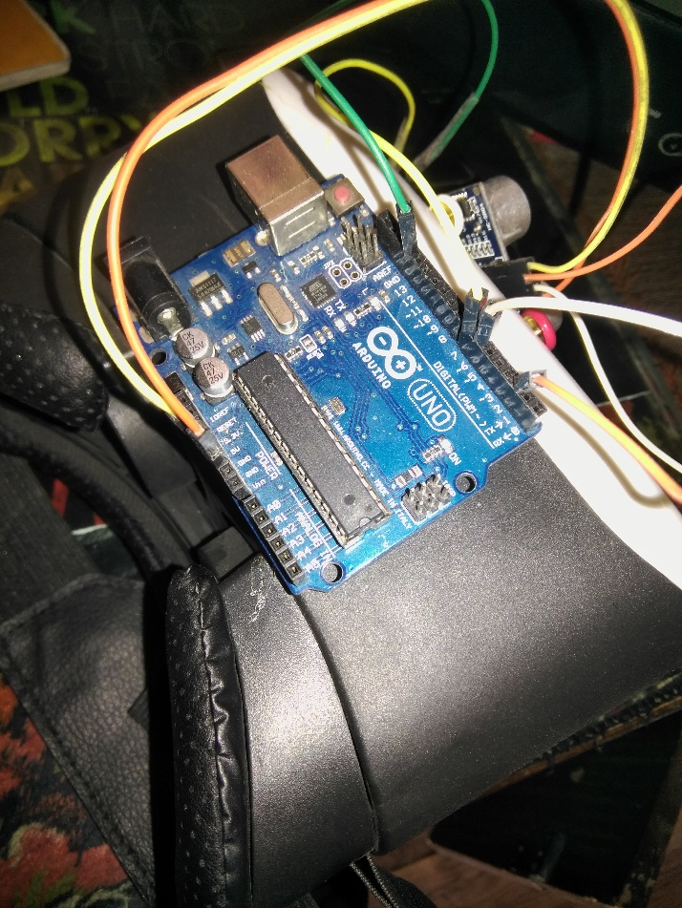

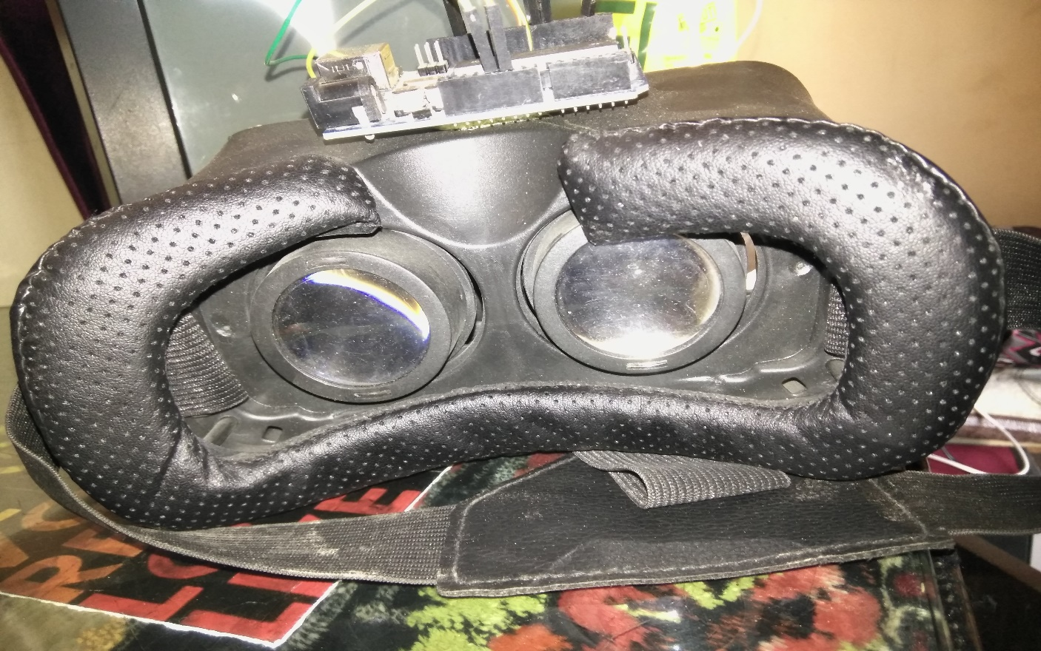

**Figure 6:- ASSEMBLED HARDWARE COMPONENTS**

**Conclusion**

This project aims at detecting nearby objects accurately with the help of Ultrasonic sensors. Arduino software along with the concepts of Embedded C were used in order to successfully accomplish the project.

**Bibliography**

* <https://www.tutorialspoint.com/arduino/arduino_ultrasonic_sensor.htm>
* <https://www.google.com/search?biw=1366&bih=608&ei=bdq6XITxO82SwgPiuqzwDg&q=arduino+ide+system+requirements&oq=Arduino+application+syst&gs_l=psy-ab.1.0.0i22i30j0i333l4.79038.84314..85841...0.0..0.331.3517.0j7j9j1....3..0....1..gws-wiz.......0i71j35i39j0i67j0i20i263j0j0i13j0i13i30.bOuoCqIWBCo>
* <https://www.google.com/search?q=arduino+wikipedia&oq=arduino+wiki&aqs=chrome.0.69i59j69i57j69i60l2j0l2.4111j0j7&sourceid=chrome&ie=UTF-8>
* <https://www.google.com/search?q=ultrasonic+sensor+wiki&oq=ultr&aqs=chrome.0.69i59l2j0j69i57j69i60l2.2849j0j9&sourceid=chrome&ie=UTF-8>
* <https://www.google.com/search?q=buzzer+wikipedia&oq=buzzer+wiki&aqs=chrome.0.0j69i57j69i60j0l3.6888j0j9&sourceid=chrome&ie=UTF-8>
* <https://www.google.com/search?q=embedded+systems&oq=embedded&aqs=chrome.3.69i57j69i61j0l4.9794j0j9&sourceid=chrome&ie=UTF-8>
* <https://www.google.com/search?q=exploreembedded&oq=exploreembedded&aqs=chrome.0.0j69i60j0l4.5949j0j9&sourceid=chrome&ie=UTF-8>